Aws region:

Aws Diagram’s: [AWS Diagrams](https://www.edrawsoft.com/aws-diagram-examples.html)

**AWS Architecture Diagrams:**

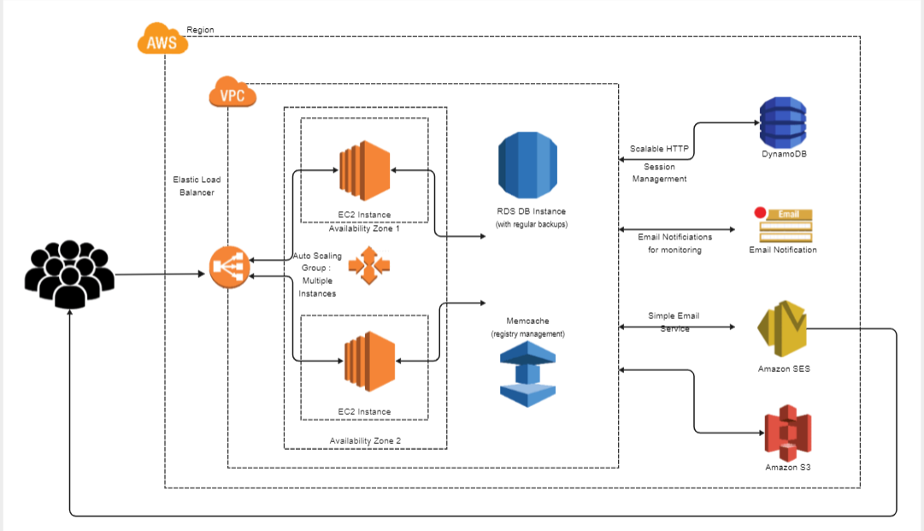

**AWS Services with Road Map**

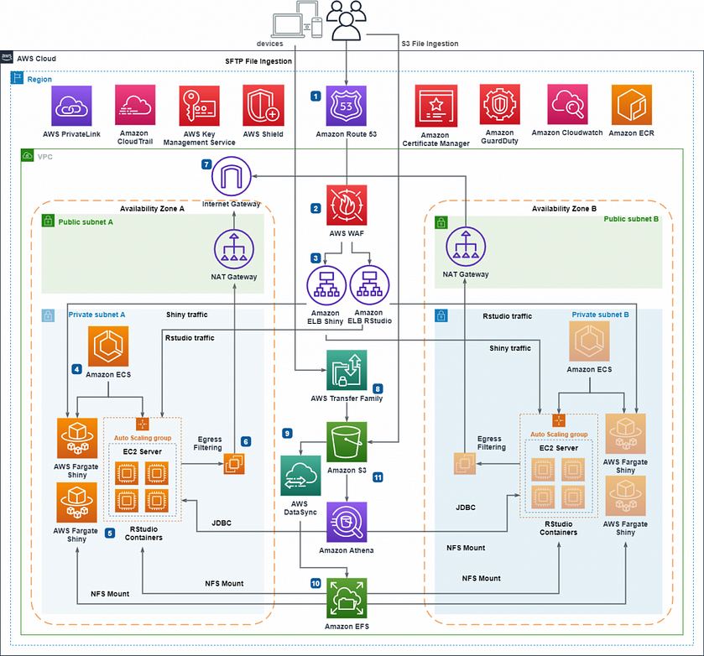

As of now 30 Launched Regions

Reference link: [Regions and avZones List](https://aws.amazon.com/about-aws/global-infrastructure/?p=ngi&loc=0)

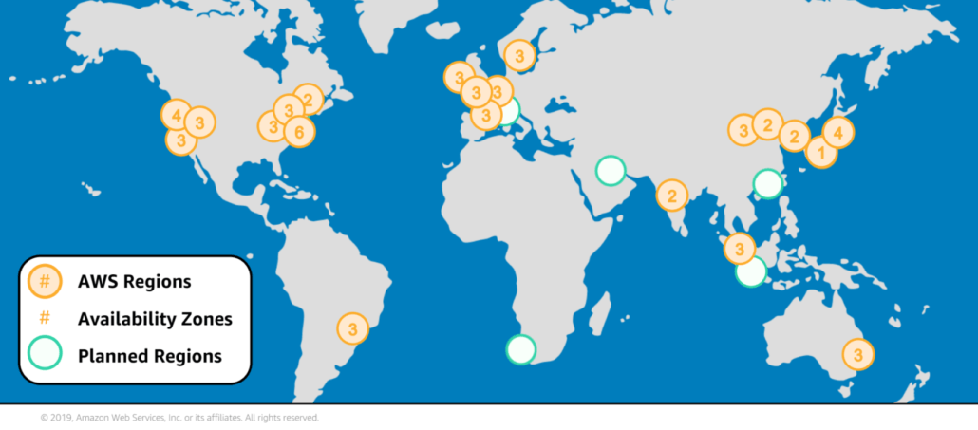

**Design for zones in region**

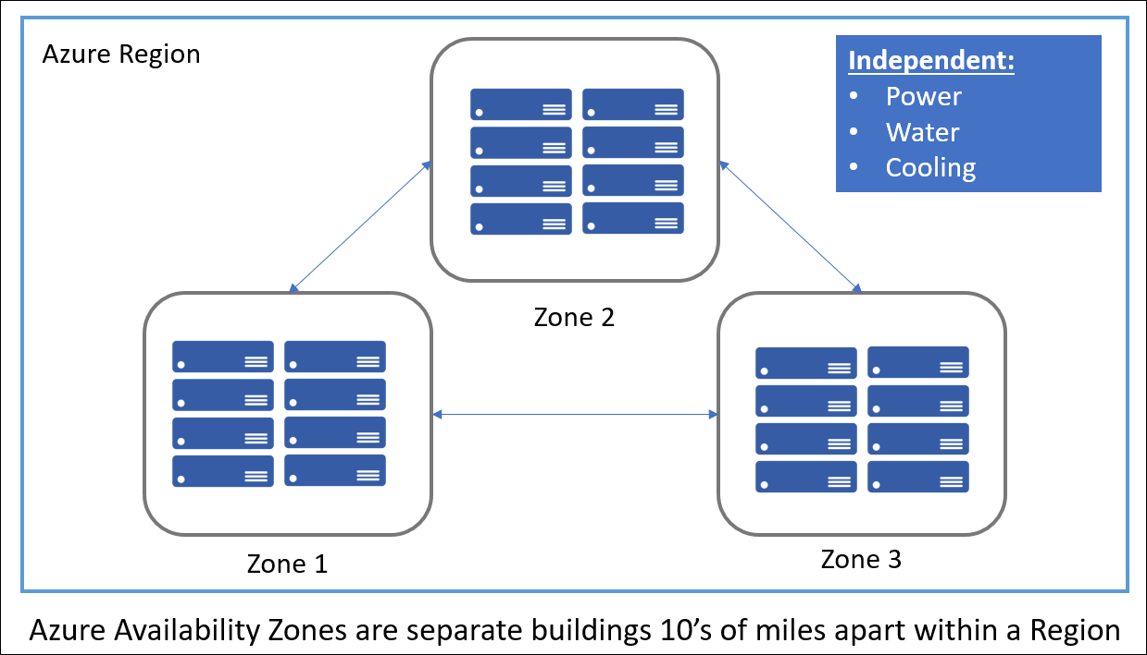

**Design for Datacenters in Availability Zones**As of now 96 Availability Zones

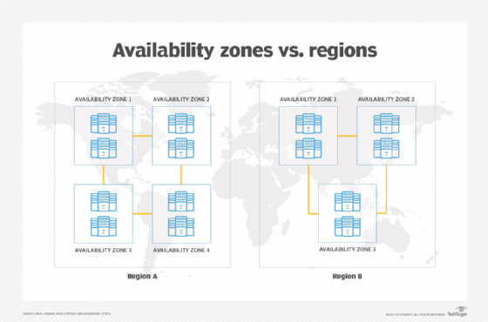

**Example of Region and AVZone and data centers**

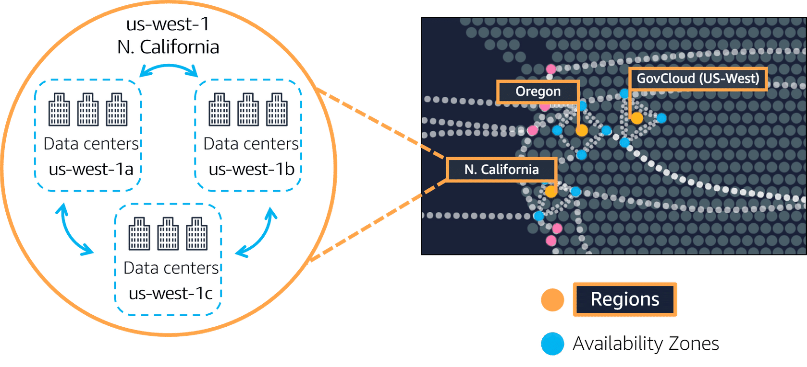

**Datacentre:**



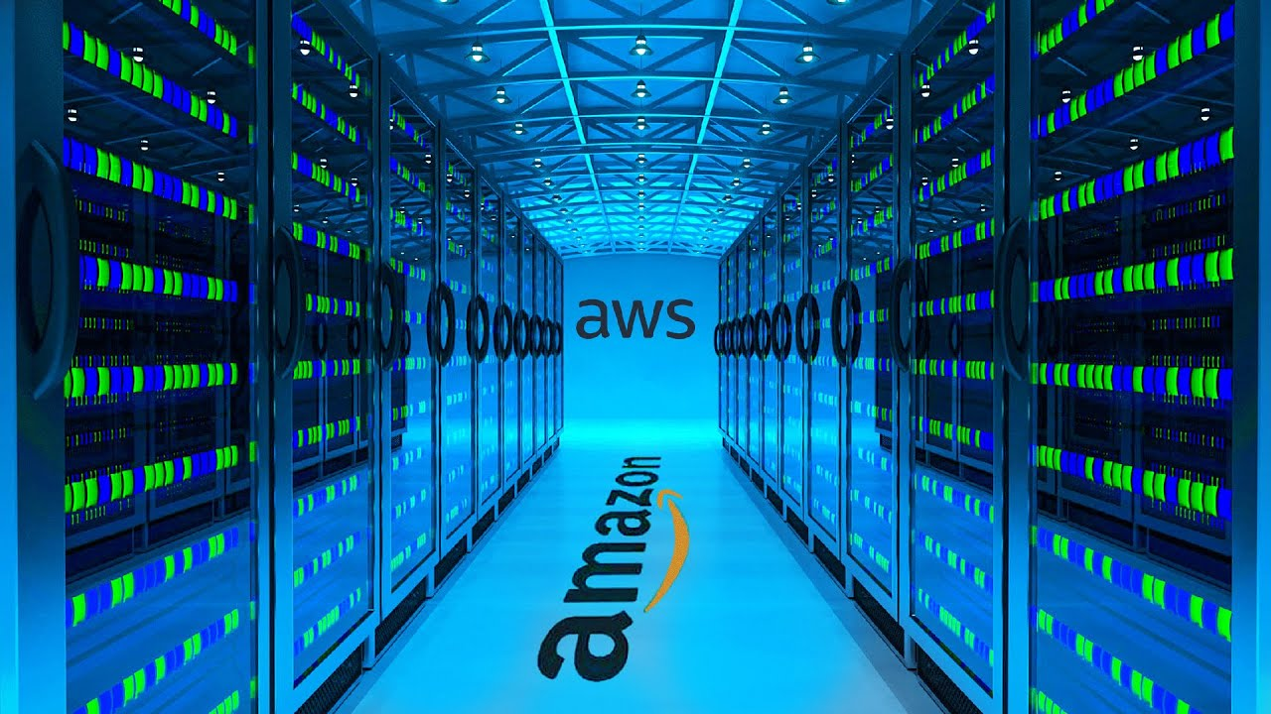

**Inside data Center View:**

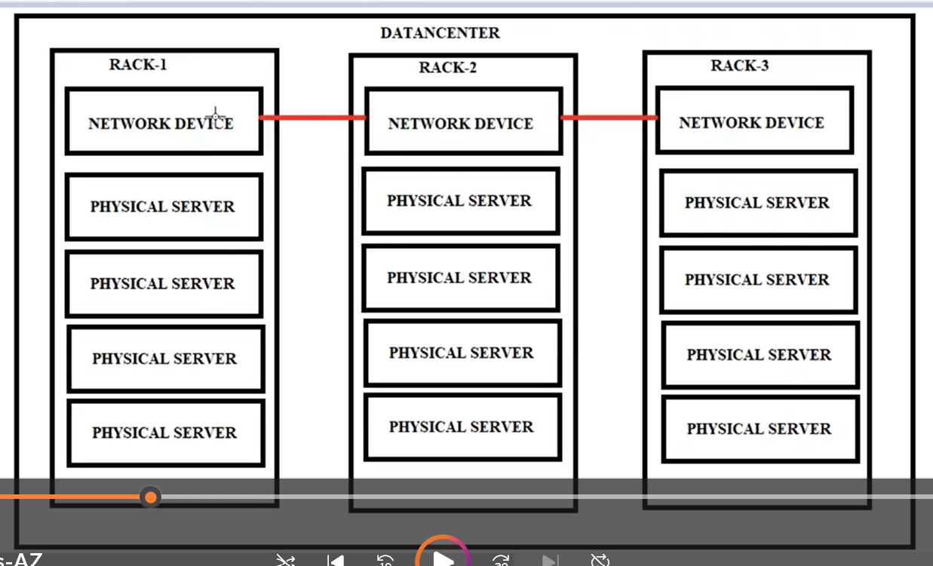



**IP Addressing:** [**ip caluclator**](https://jodies.de/ipcalc)

2 types of Ip’s

1. IpV4 – 32bit – 4 octats
2. Ipv6 – 128 bit – 6 octats

Difference between Private and public ip ranges:

Ex: 10th class

Rollno (private) - same 2 ips are available with different vpc.( its valid only internal)

hall ticket(public)- we cant get 2 ips are same.( its valid only internet)z

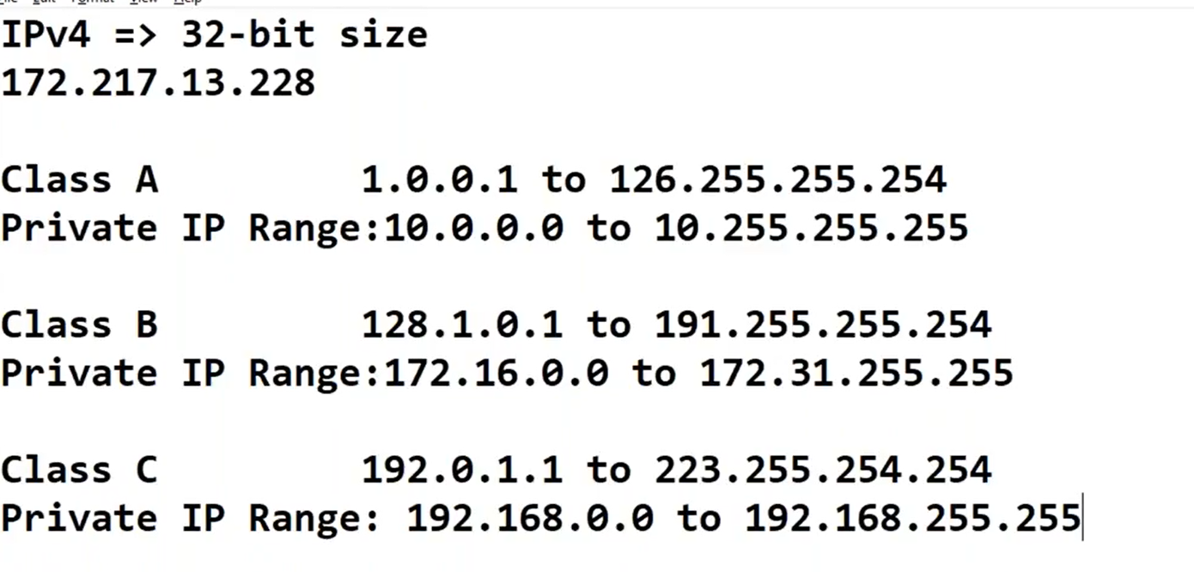

To known each bit range

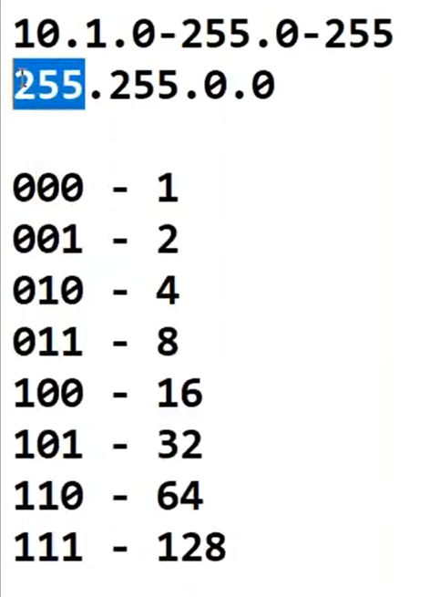

Subneting: (or) netmask:

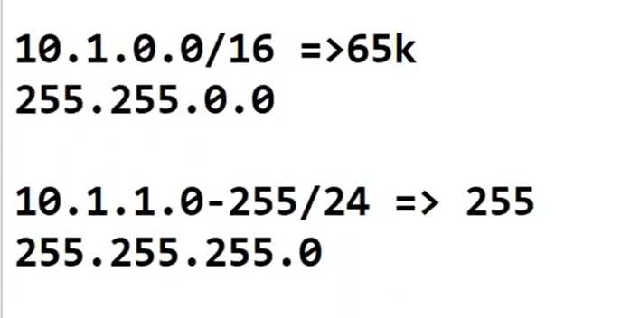

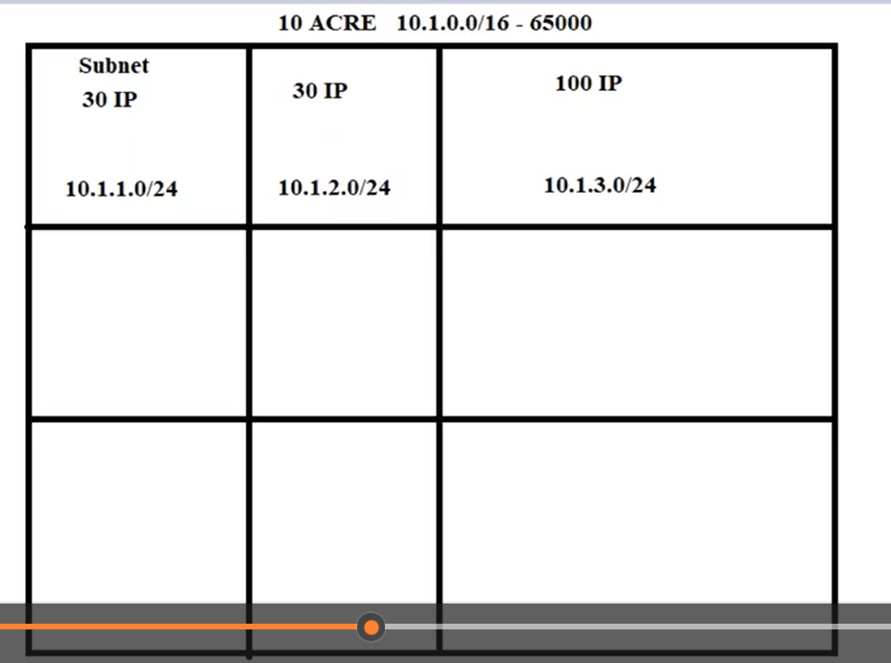

By using subne calculator to divided ip ranges as per our requirements.

Aws resereved ips :

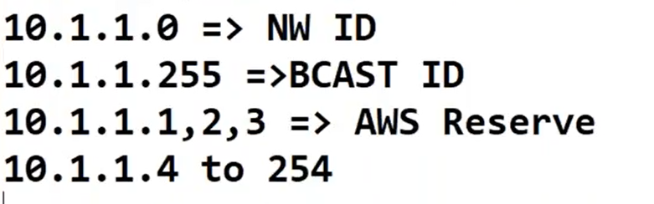

Vpc setup:

3 vpcs are internally commuting with theire vms

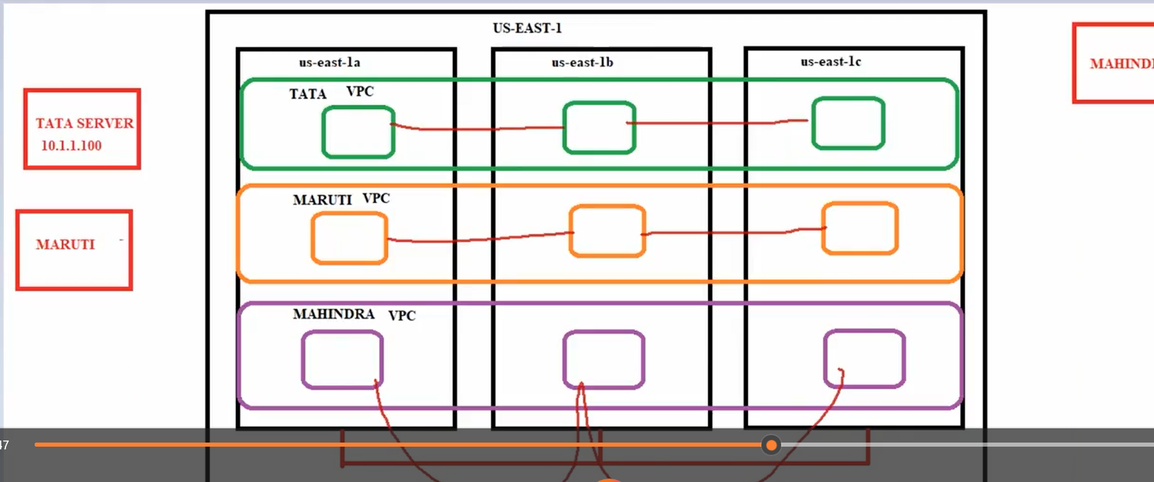

3 vpc are not communicating with with their vms

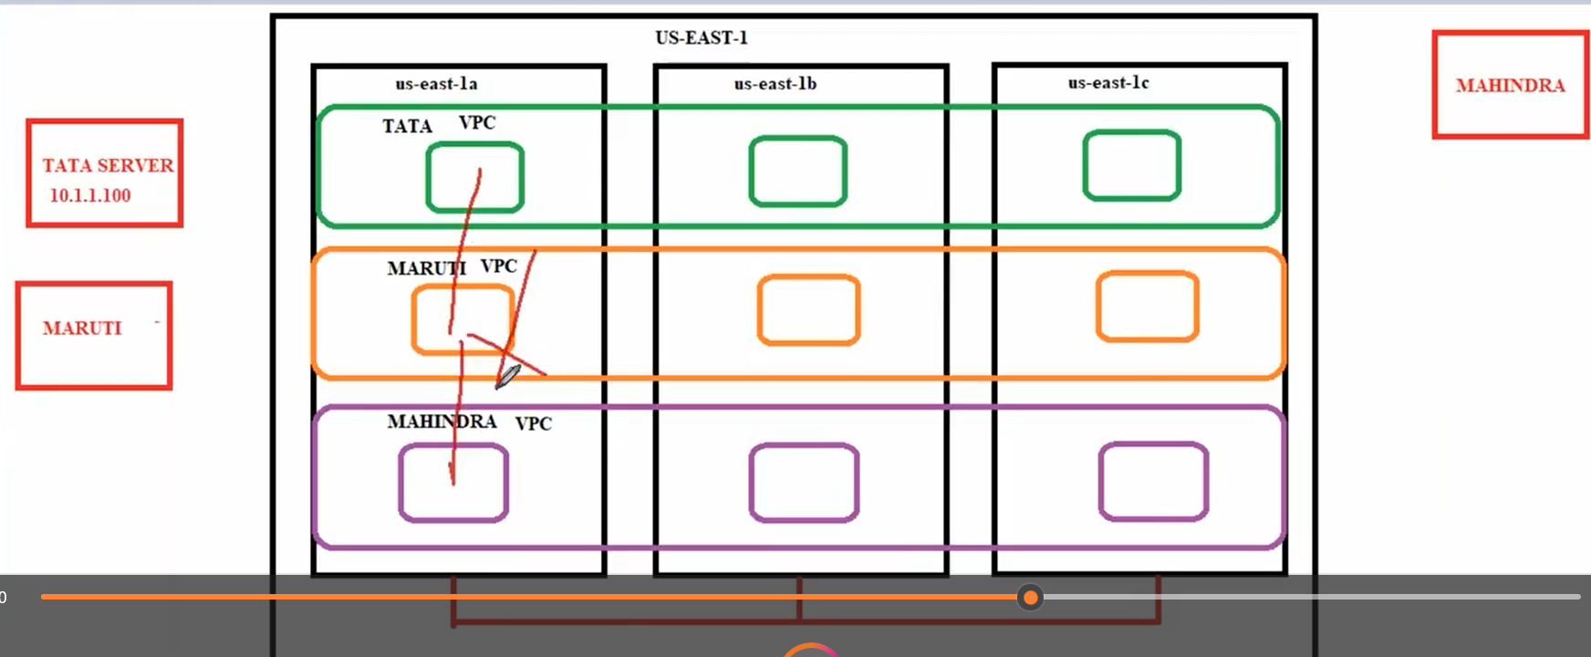

Aws infrastructure for vpc, subnet, route table, internet gateway, internet:

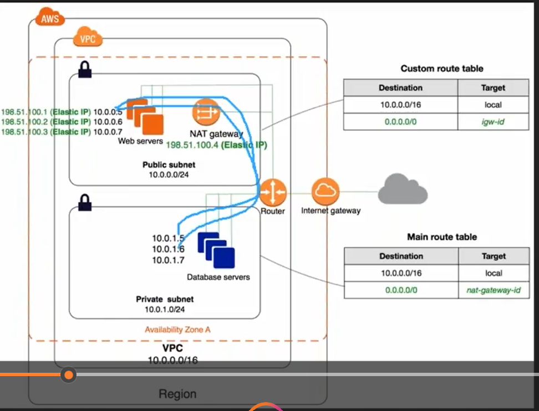

Finally vm creation inside our own vpc setup:

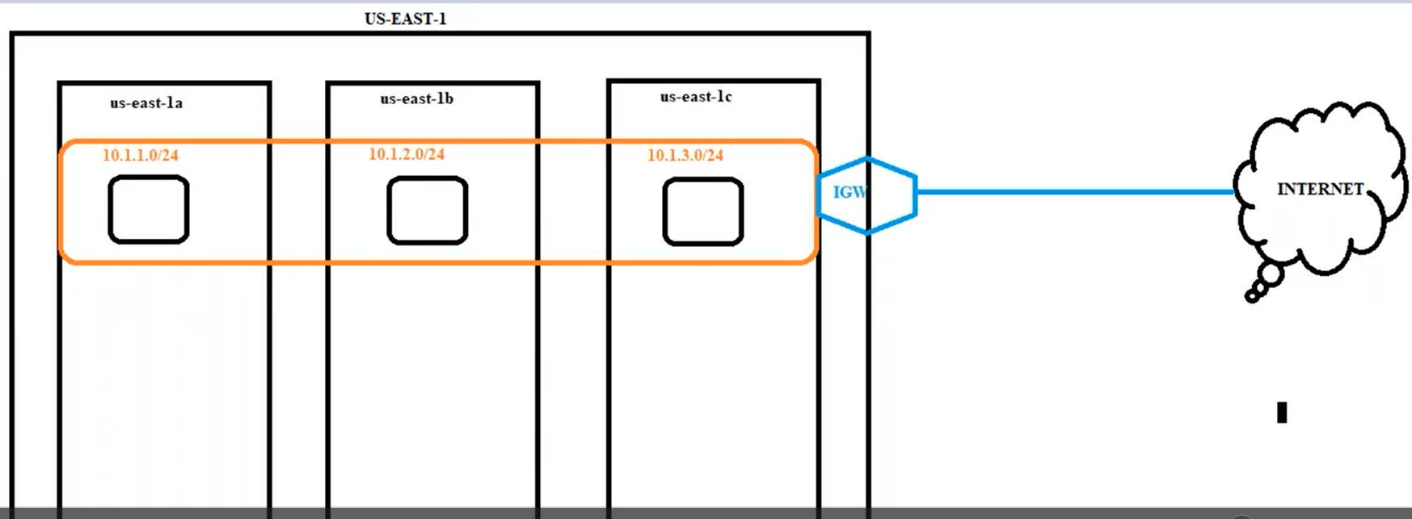

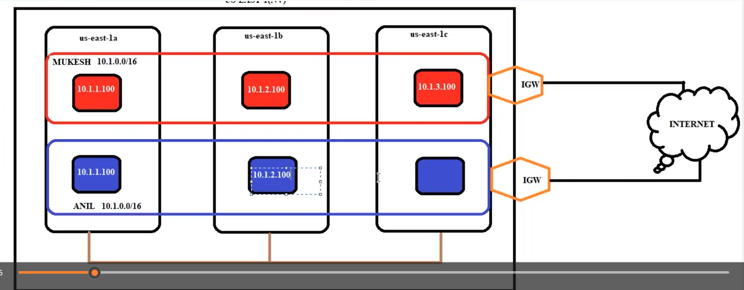

Vpc peering:

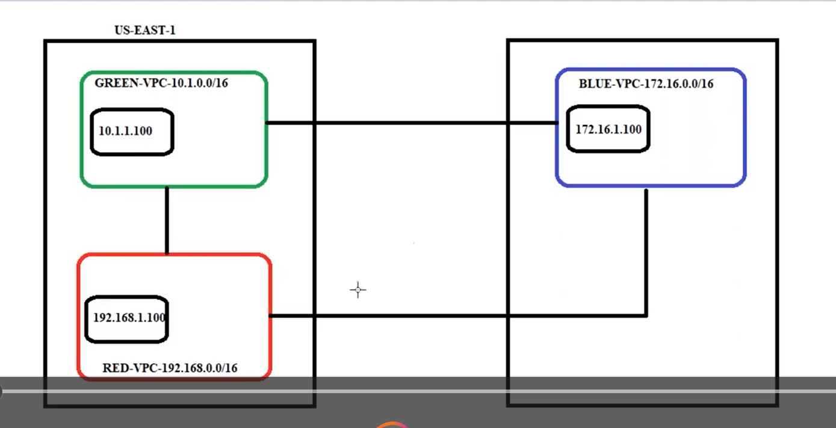

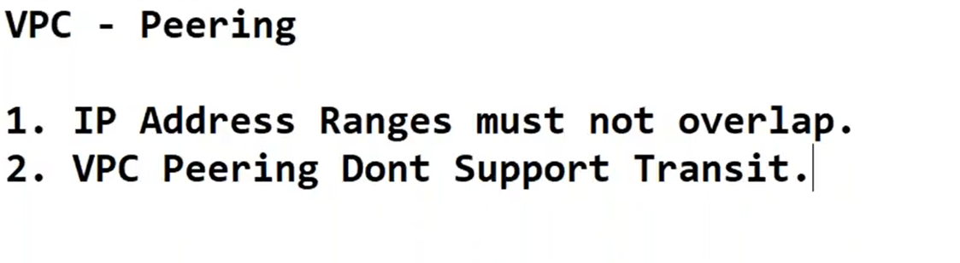

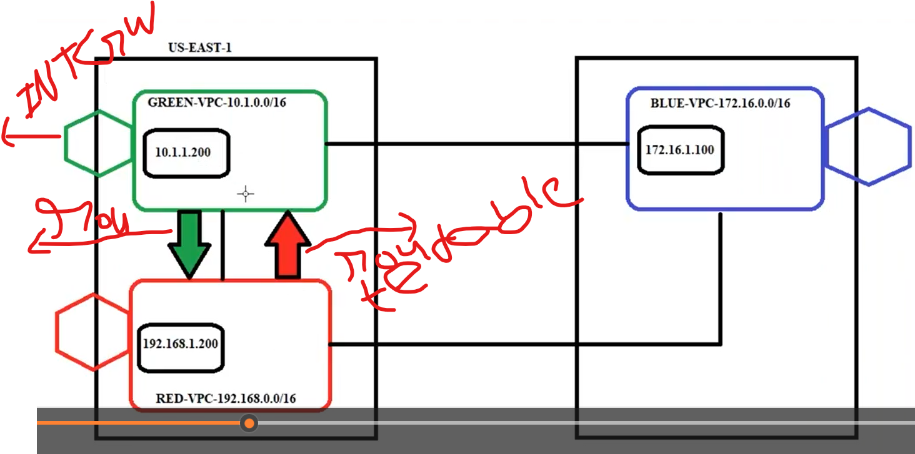

NAT Gateway:

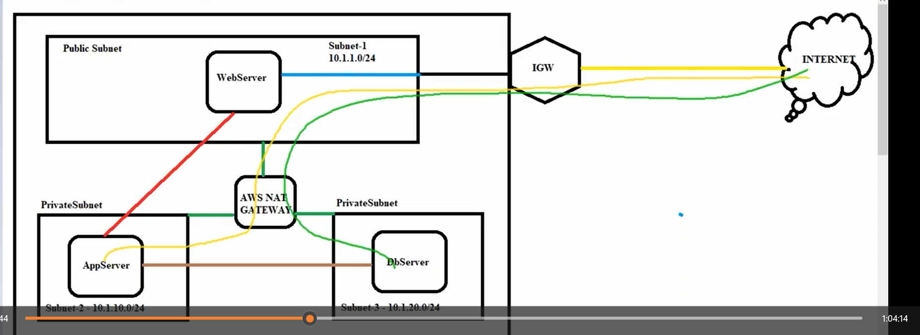

1. When the creation of Nat gateway attached to public Subnet.
2. In the route table, create Nat route table in that private subnet associated and routes rule added into Nat gateway.

NAT works:

Example office security guard ( like entry it will check but exit will not check)

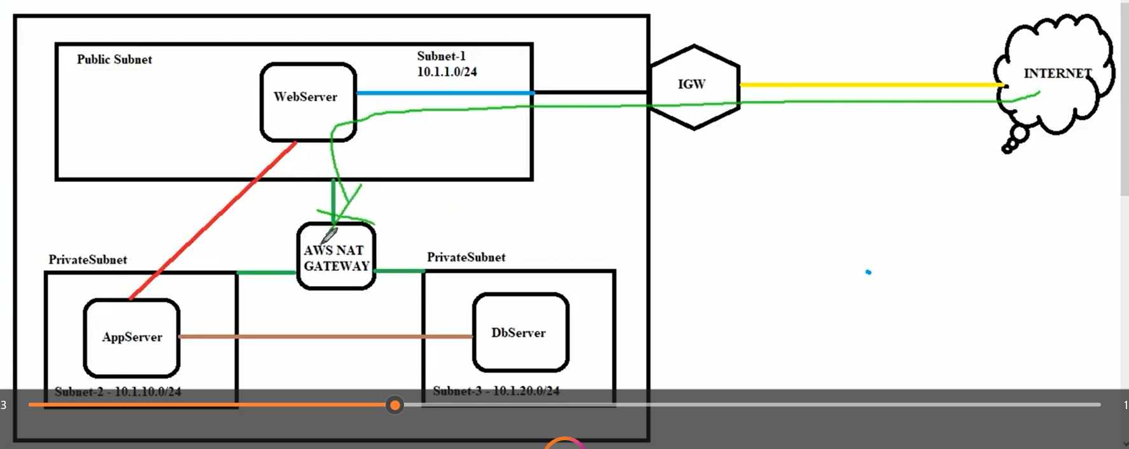

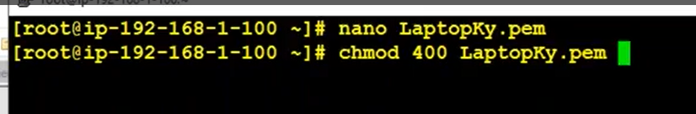

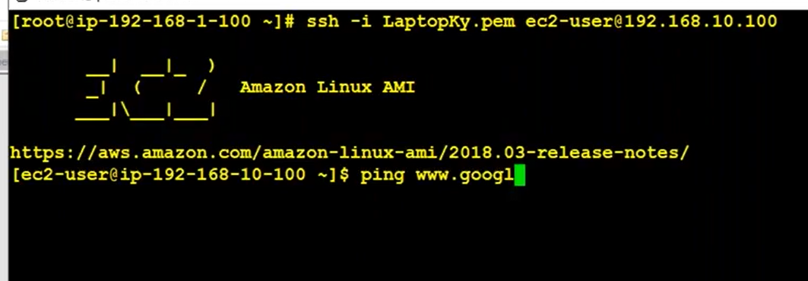

Nat gateway:

A NAT gateway is a Network Address Translation (NAT) service.

NAT Gateway is **a highly available AWS managed service that makes it easy to connect to the Internet from instances within a private subnet in an Amazon Virtual Private Cloud (Amazon VPC)**. Previously, you needed to launch a NAT instance to enable NAT for instances in a private subnet.

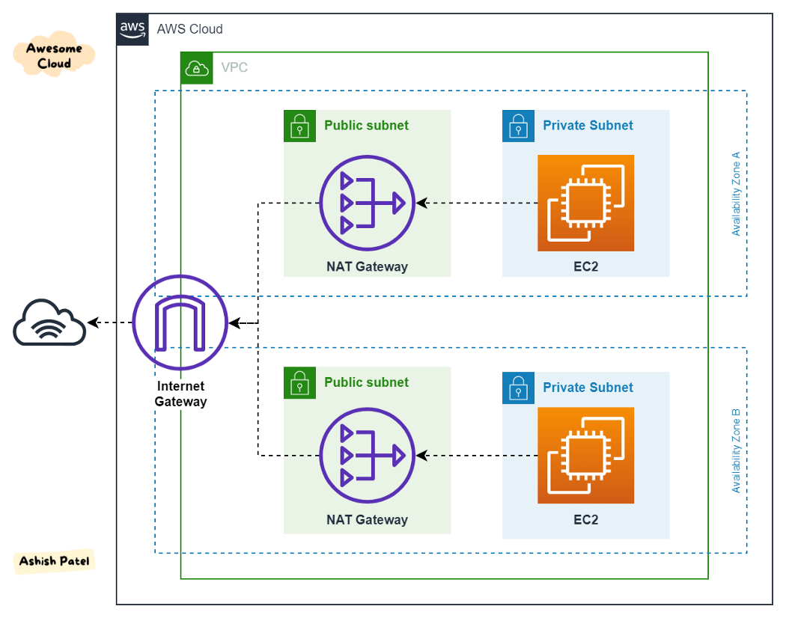

Vpc endpoints:

VPC endpoints means communicate with internet using private server help of public server.

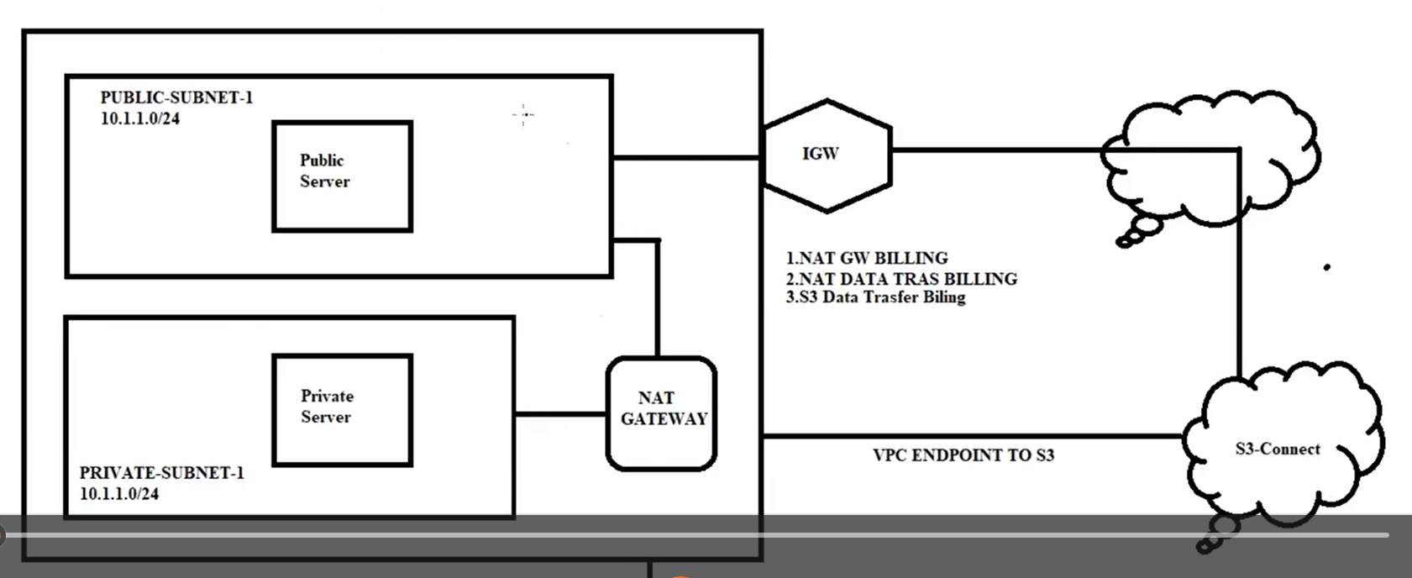

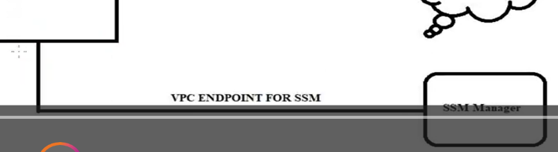

Using Nat gateway connect one resource to another resource

1. Manually upload a file in s3 bucket
2. Through cli upload a file ins3 bucket

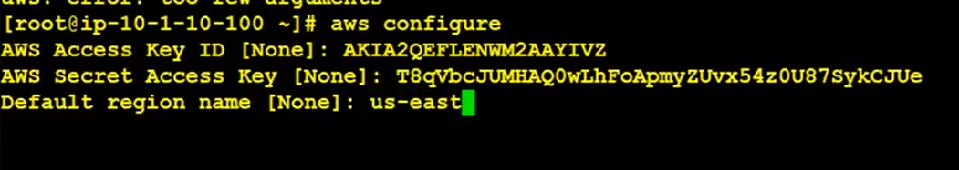

Cmd for upload a file in s3 bucket

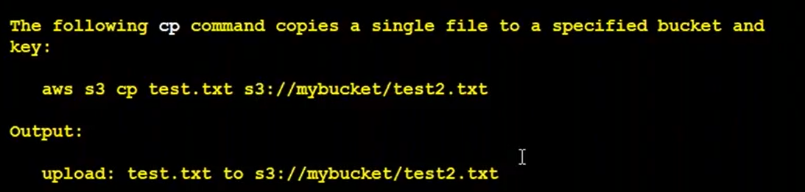

Go to s3 bucket in that we are upload a file make file as public access and copy the link past in vm using curl -sL path (executing s3 bucket file)

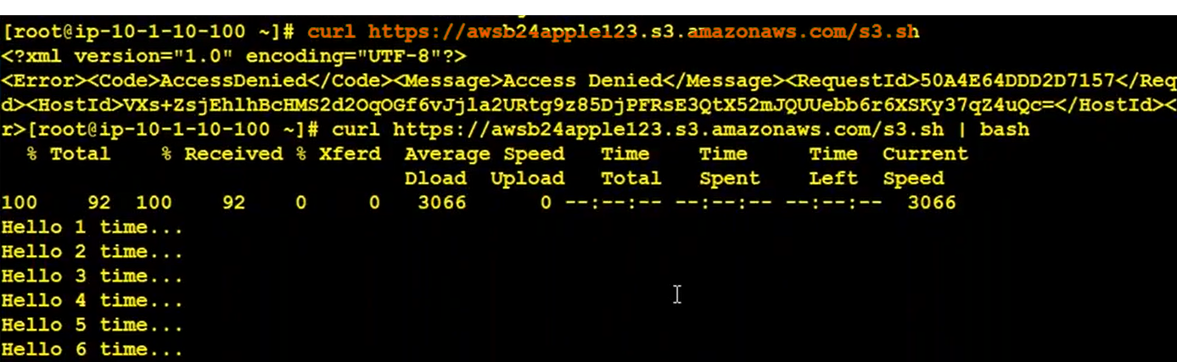

Download a file from s3 to vm



End Points are 2 types

1. Gateway (applicable only s3, DynamoDB) (just replace natgaeway)

When ever you create endpoint using Gateway By default it will create one route in pvt routetable.

Upload files in s3 using cmd through vm

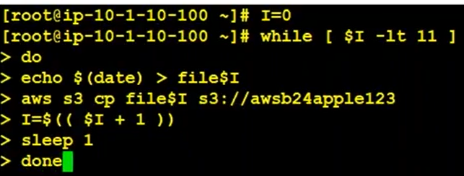

Download files



Executing file

Curl -sL <path>

1. Interface (except s3, DynamoDB remaining all)

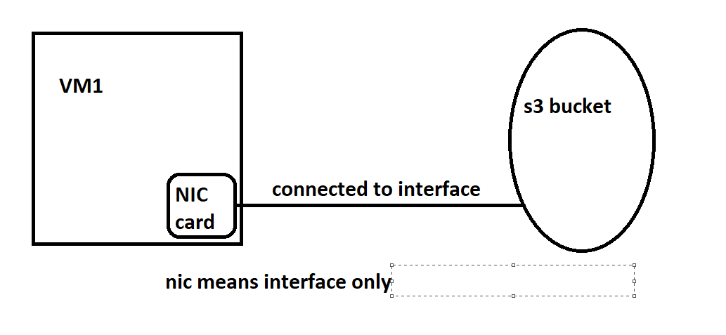

Create a role in iam with ec2 instance next permission then the below page open 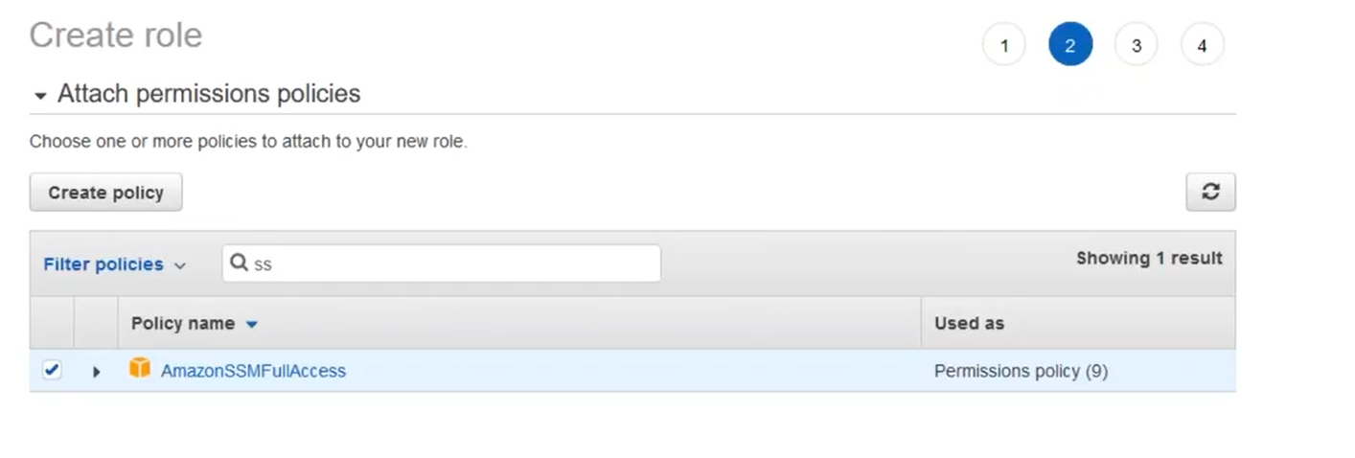

Then select permission and create a role.

Go to session manager resource and check their our ec2 instance.

Initially it will show ec2 instance (only have public ip and public vm)

And also we see private vms also then create a below endpoints for vpc, subnet, and sgs then only we see.

Create 3 endpoints for your particular vpc subnet sg

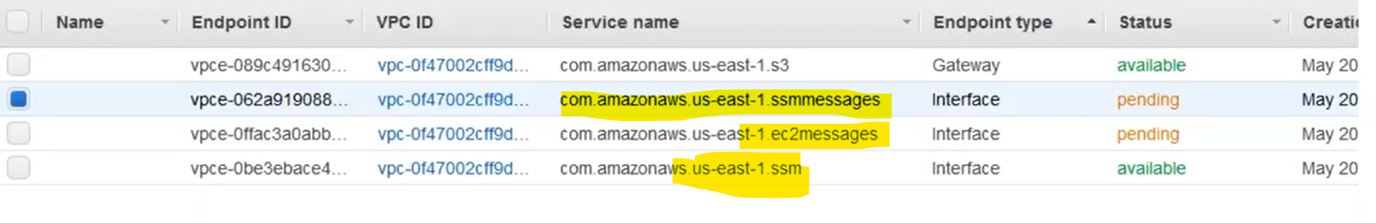

Then Attach a role with existing ec2-instance and reboot the server. Check in the session manager it will appear all private and public vms and connect session manager.

Nacl vs Security groups:

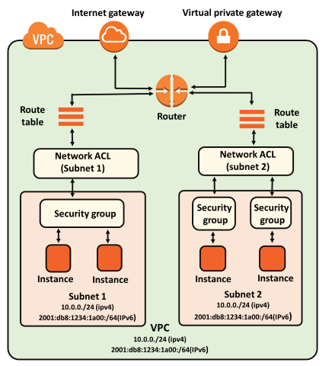

|  |  |
| --- | --- |
| **Security Group** | **NACL (Network Access Control List)** |
| It supports only **allow** rules, and by default, all the rules are denied. You cannot deny the rule for establishing a connection. | It supports both **allow and deny** rules, and by default, all the rules are denied. You need to add the rule which you can either allow or deny it. |
| It is a **stateful** means that any changes made in the inbound rule will be automatically reflected in the outbound rule. For example, If you are allowing an incoming port 80, then you also have to add the outbound rule explicitly. | It is a **stateless** means that any changes made in the inbound rule will not reflect the outbound rule, i.e., you need to add the outbound rule separately. For example, if you add an inbound rule port number 80, then you also have to explicitly add the outbound rule. |
| It is associated with an EC2 instance. | It is associated with a subnet. |
| All the rules are evaluated before deciding whether to allow the traffic. | Rules are evaluated in order, starting from the lowest number. |
| Security Group is applied to an instance only when you specify a security group while launching an instance. | NACL has applied automatically to all the instances which are associated with an instance. |
| It is the first layer of defense. | It is the second layer of defense. |

Transit GateWay:

Vpc peering disadvantage

Peering is a one to one connection

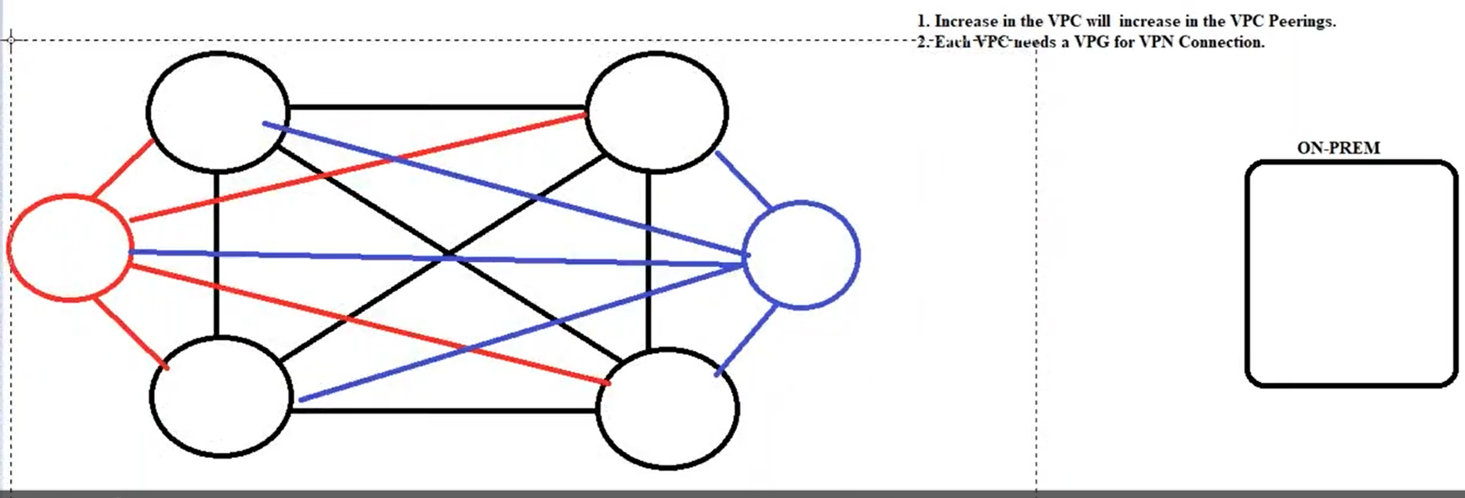

To overcome the problem using TransitGateway

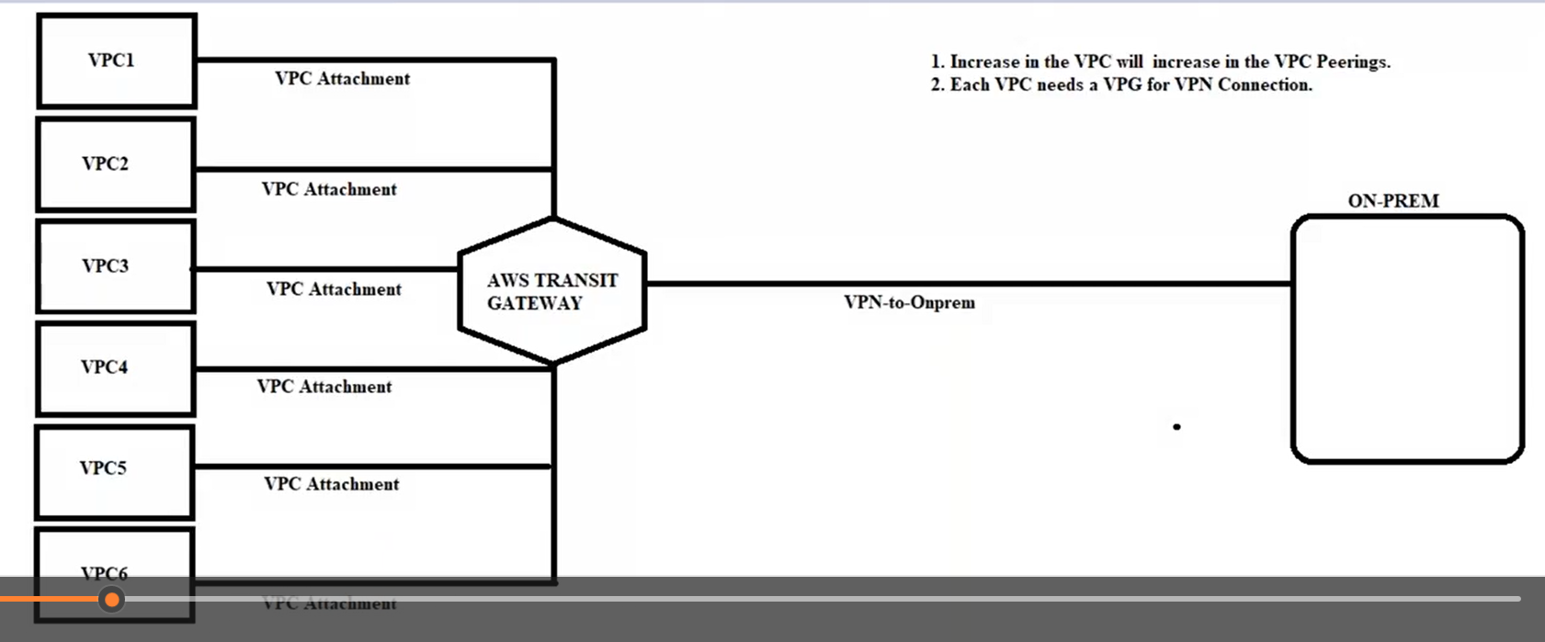

1. Create an Attachement using, #VPC ALL(6vpc)
2. Create route in route tables #VPC ALL(6vpc)

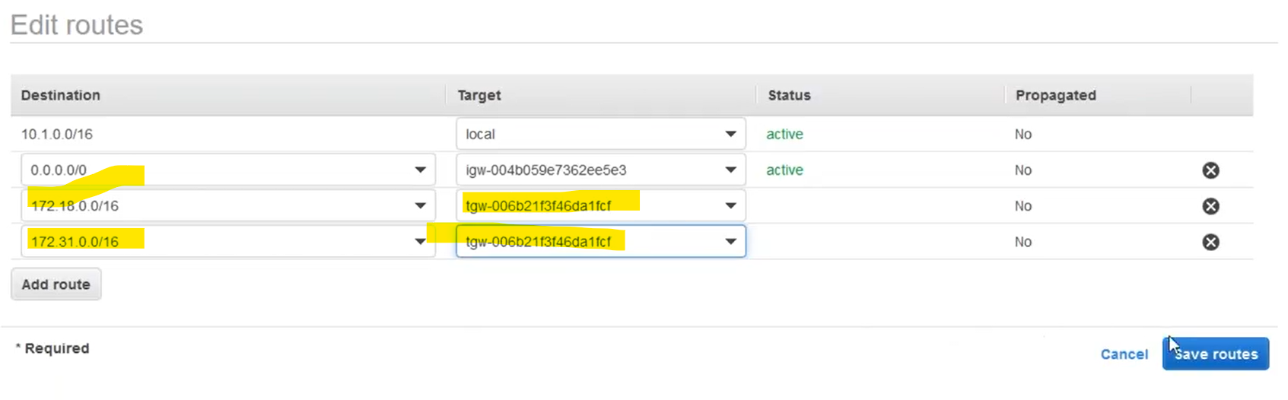

1. Internally communication is done b/w vpc

Transit gate way with different region

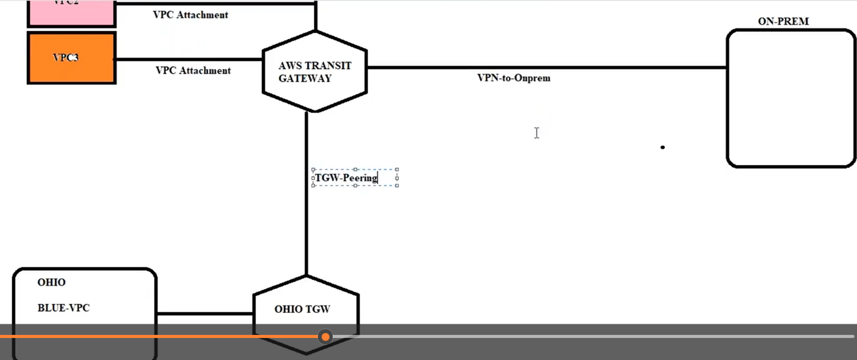

1. Go to ohio region create vpc, subnet, rt.
2. Create transit gateway and transit gateway attachment and transit gateway peering with different region .
3. Create route in route tables
4. Create route in transit gateway route table for your vpcs. # (whenever using peering use transit Gateway rt)
5. Communication done with different region vpc also.

==================== vpc end ========================

EC2 Instance:

Volumes:

Volume types  
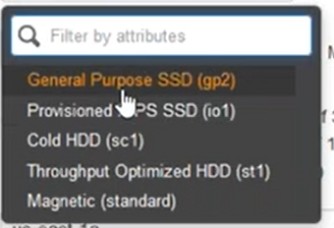  
  
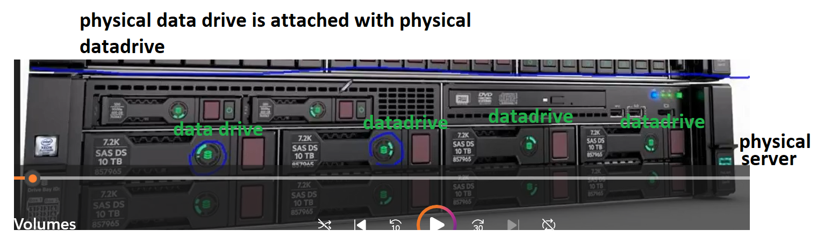

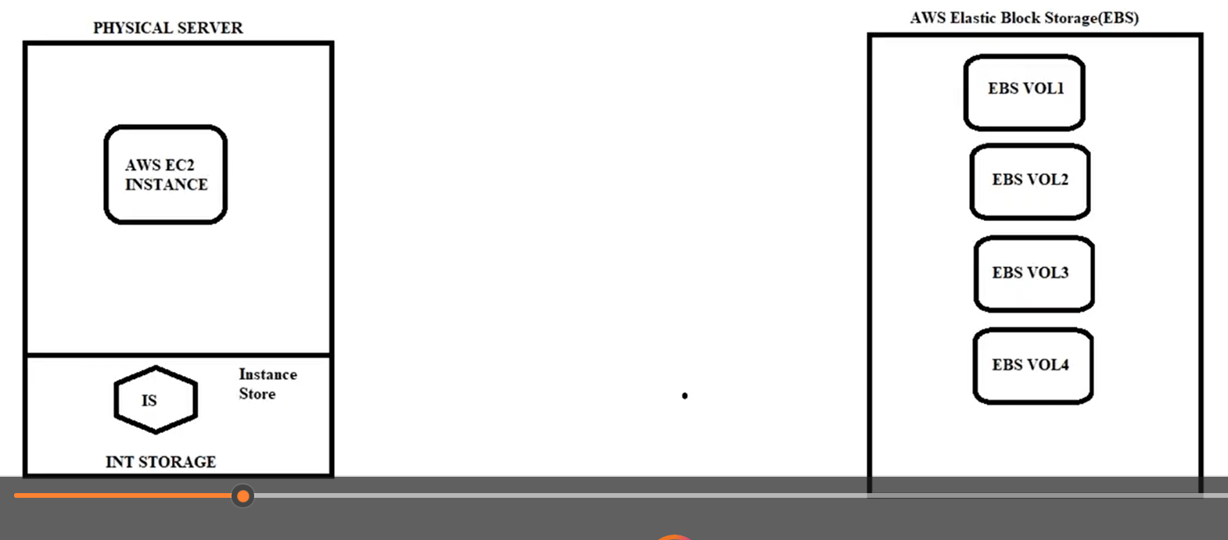

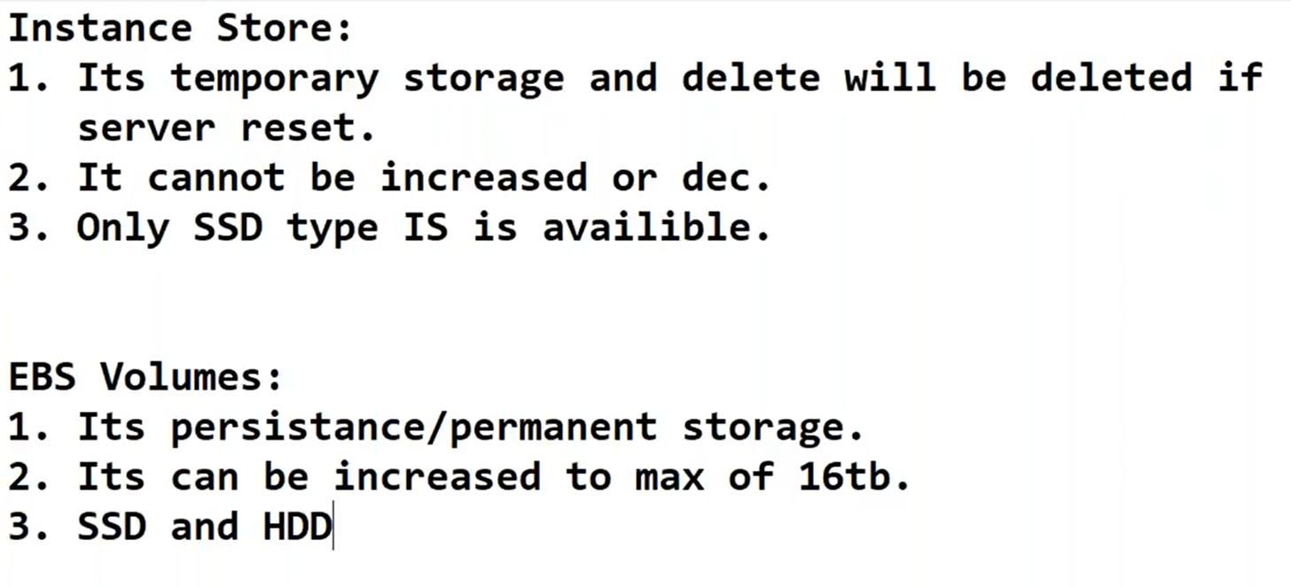

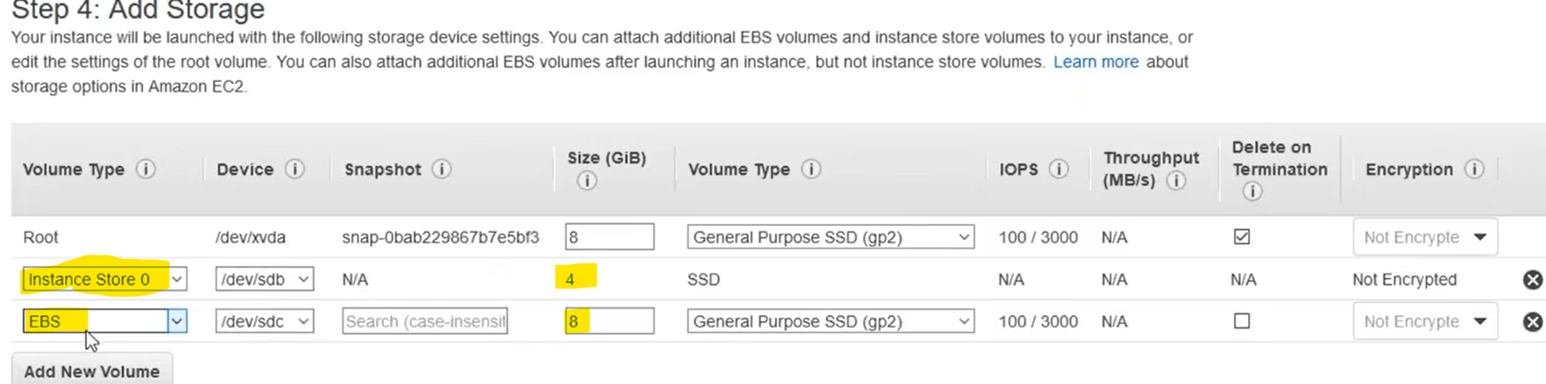

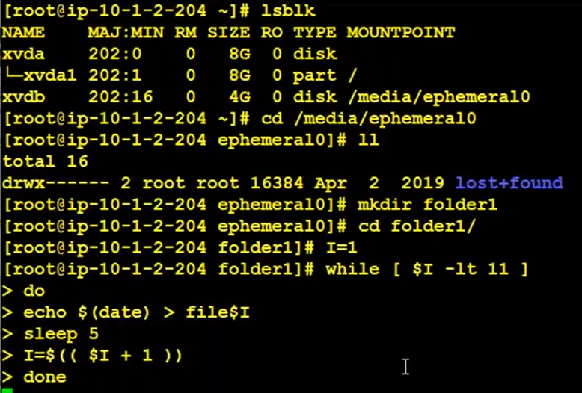

Create EBS volume and attach that volume to your VM.

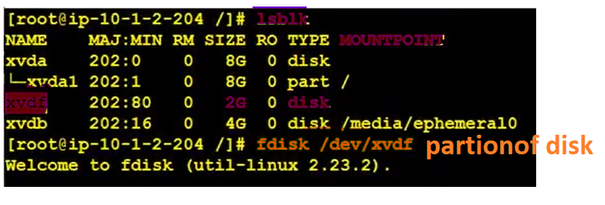

After fdisk enter type “n” and “enter” 4times and last “w”

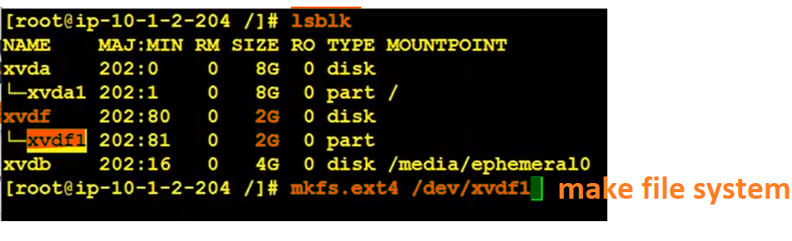

Create a folder # mkdir /myebsvol and mount your drive to that folder path

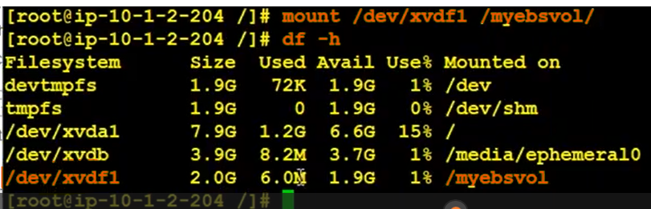

Check the data in to drives in below

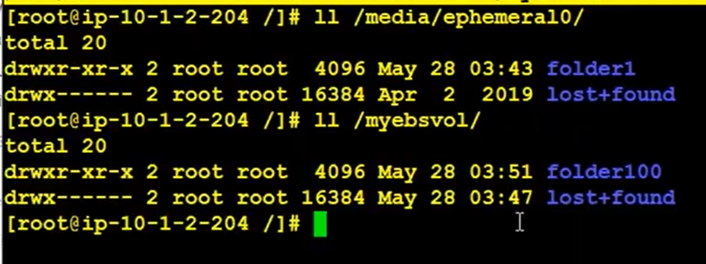

And then stop/start the vm

1.instant store data will gone

2.ebs vol folder and data is available but not see here, we have to see means put that drive name and path in “fstab”.

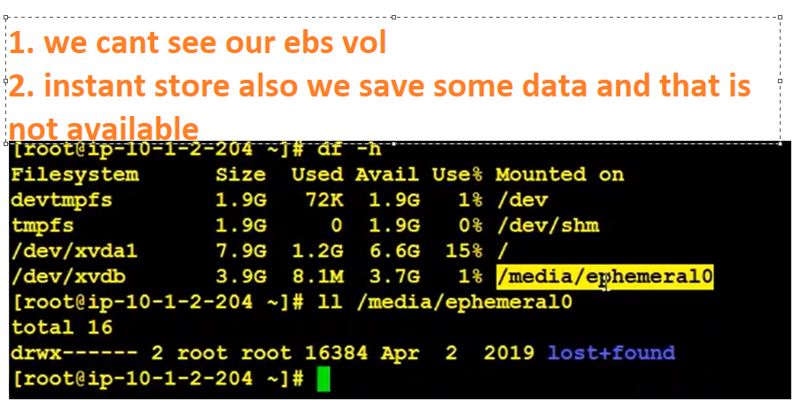

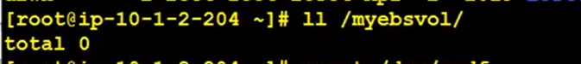

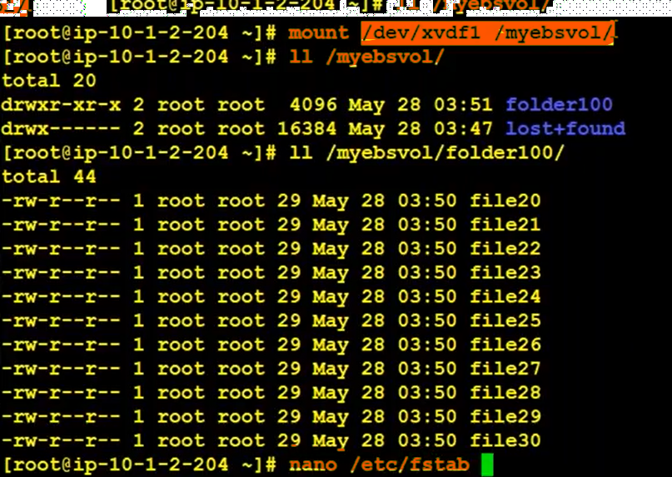

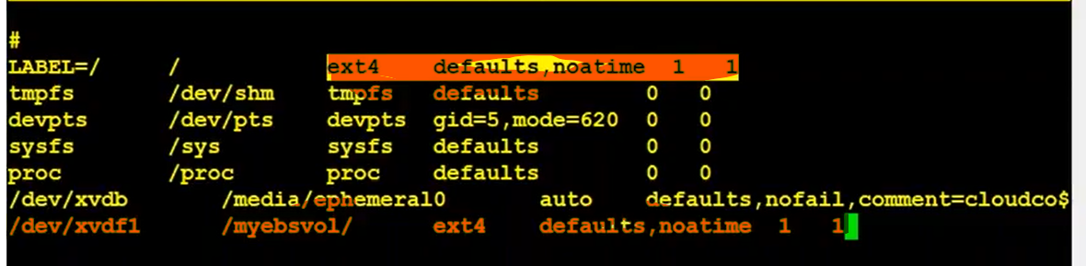

Again stop and start the vm our ebs vol is there becoz of we put data drive in fstab

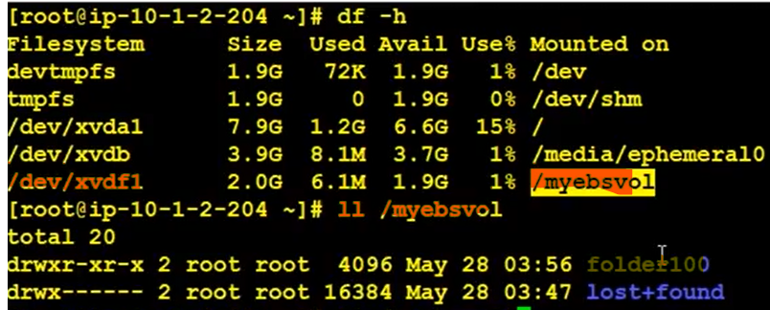

Cmds:

1. df_h (or) Lsblk (list of block)
2. umount

increase vol size in portal:

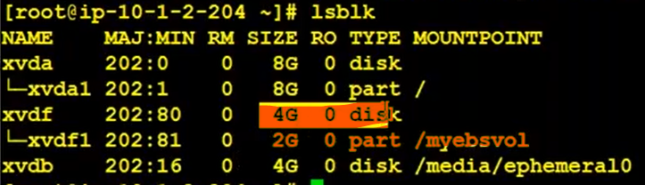

1. volumes we can move one region to another region
2. we can’t move one av zone to another av zone

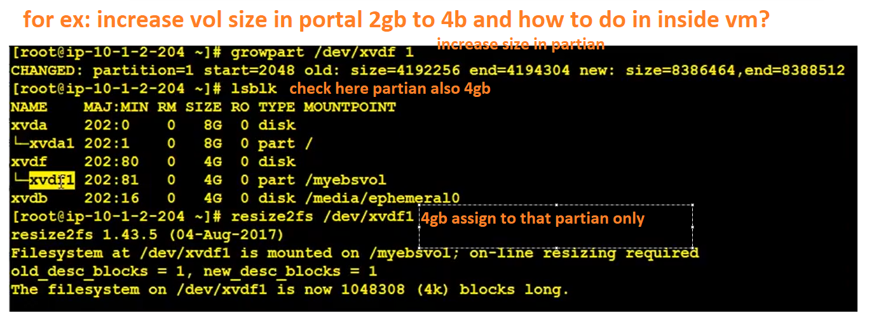

Detailed way for volumes:

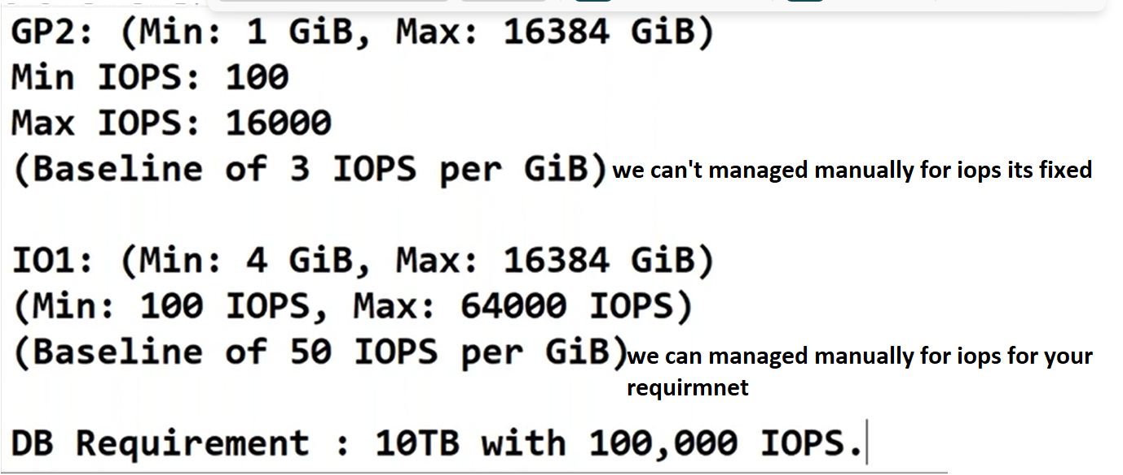

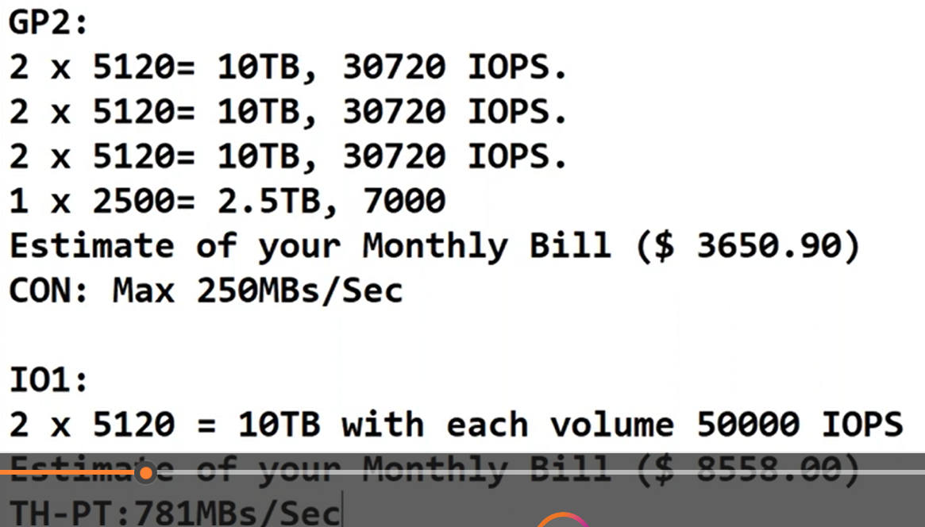

Snapshot:

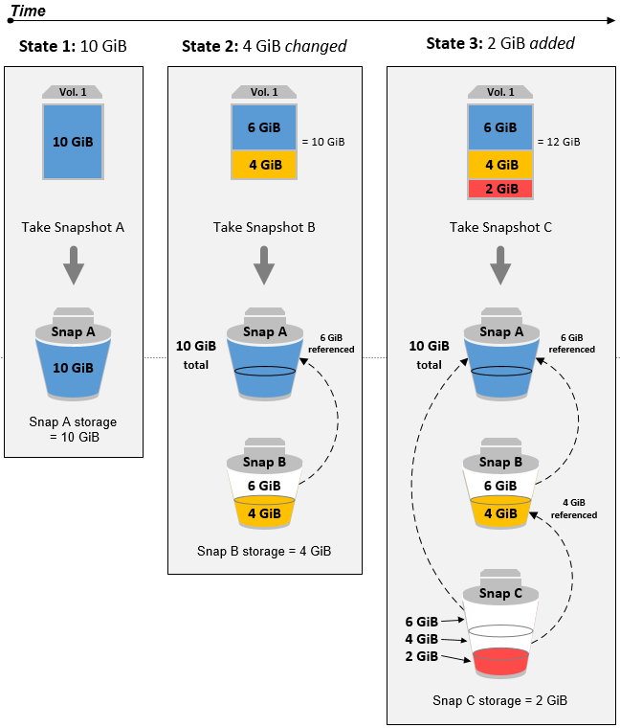

Load balancer:

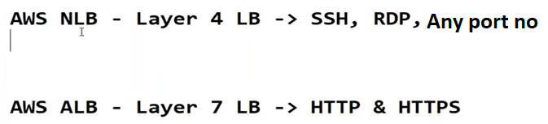

1. Network load balancer:(NLB)

It is applicable for any port number like tcp protocol and static web page

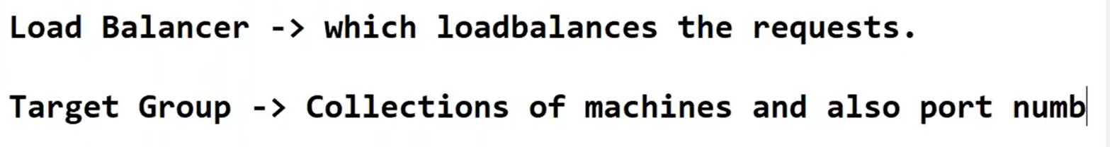

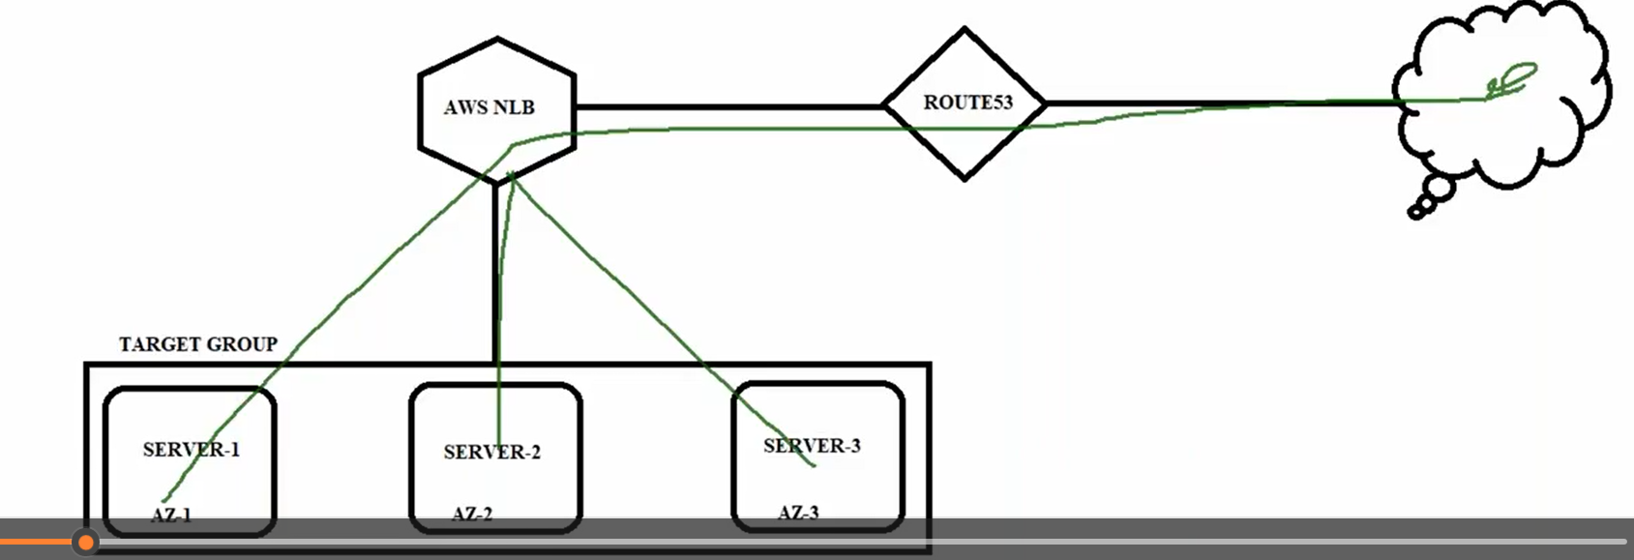

1. Create 3 vms and install nginx and add telugu comedian gifs
2. Create target group and add vms into **target tab** in below.
3. Create load balancer
4. Check the output in browser and putty

Check the output in putty

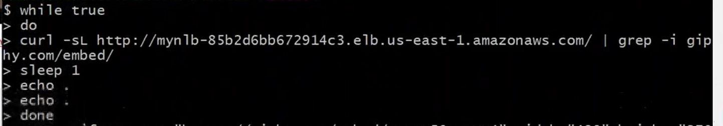

1. Our application is not a secure here. So, it should be a secure means must watch the video at 45min onwords.
2. Application Load Balancer (ALB):

It is applicable for only HTTP/HTTPS and path based routing. dyanamic web page

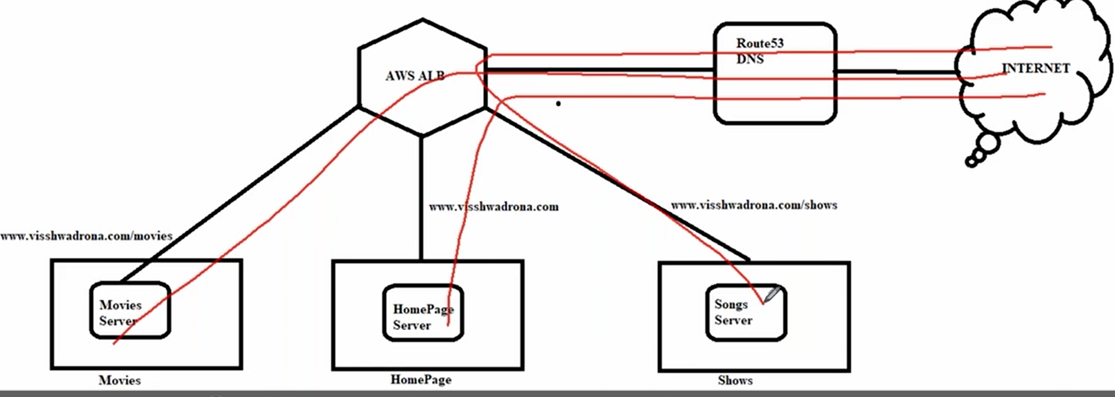

1. Create 3 vms and install nginx and edit nginx page with some images
2. Create 3-target group with path and add vms into **target tab** in below
3. Create load balancer
4. In load balancer below lister tab add paths.
5. Check the output in browser and putty.

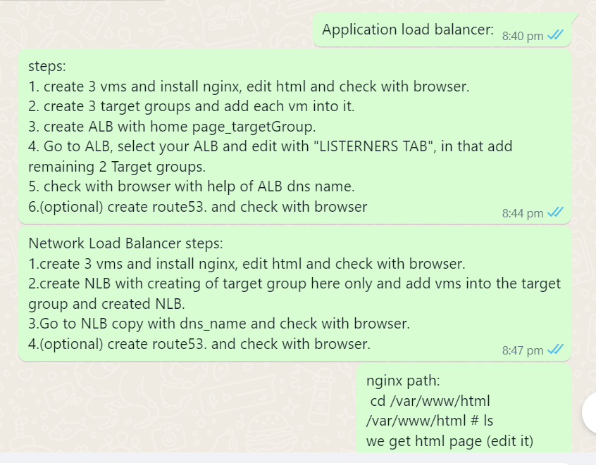

1. External-Internal load Balancer:

How do I load balance between b/w private server

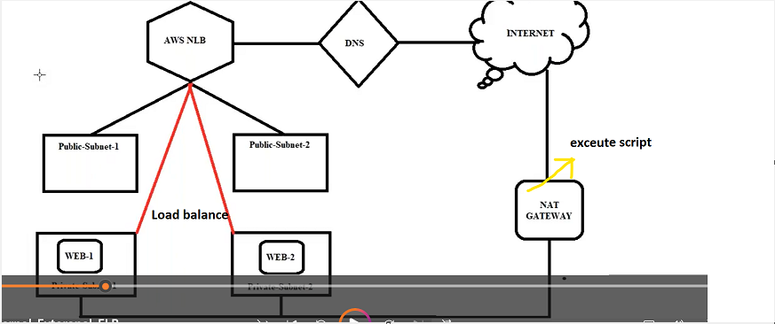

Note: Loab Balancer must be in the public subnet

VMs its should be anything is fine  
 incase vm in private subnet we use nat gateway to get internet access.

Incase vm in public subnet we use internet gateway to get internet access.

3-tier architecture

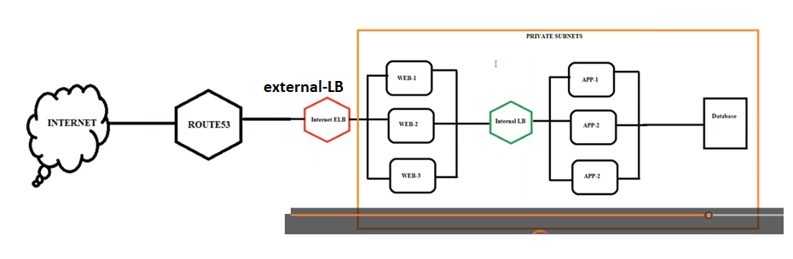

Auto Scaling:

Auto scaling used for



Types of Auto scaling

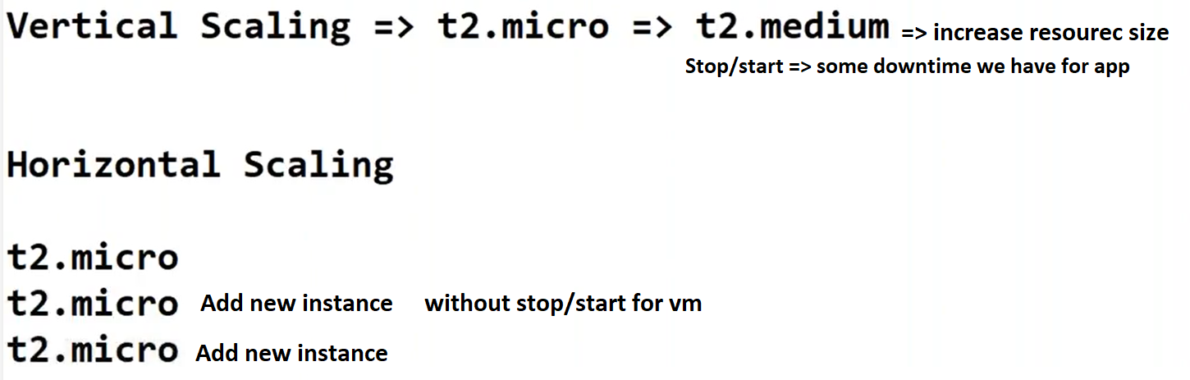

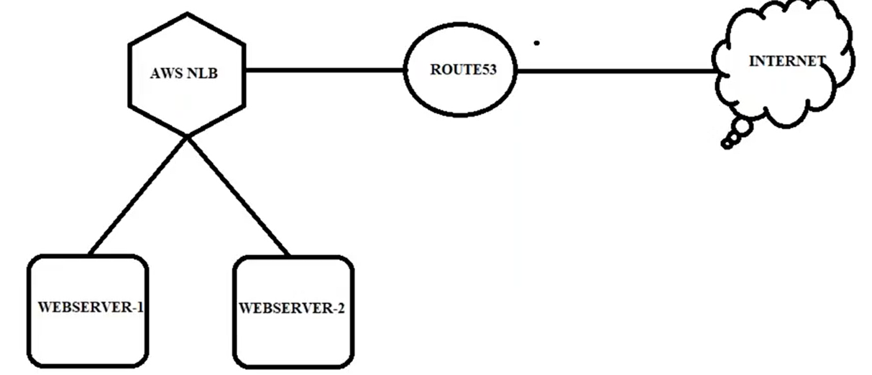

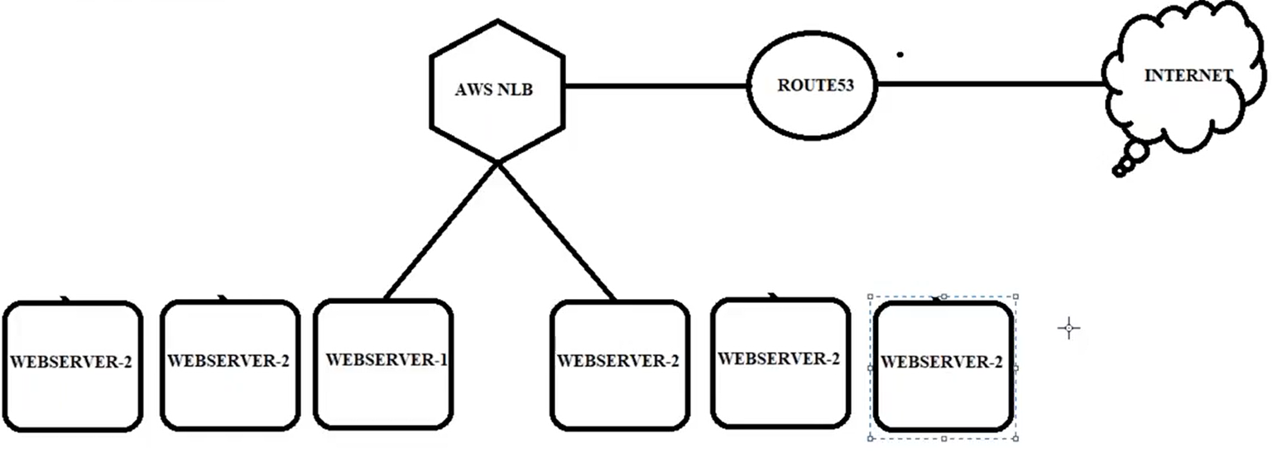

Steps:

1. Create ec2 and install git,nginx,stress





 Always nginx run on vm.

Check config nginx on for linux

1. Create an image using above vm
2. Create target group but we are not adding any machine here. (AS is automatically add vm)
3. Create NLB
4. Go to launch configuration tab create a vm
5. Create Auto Scaling groups with help of launch configuration

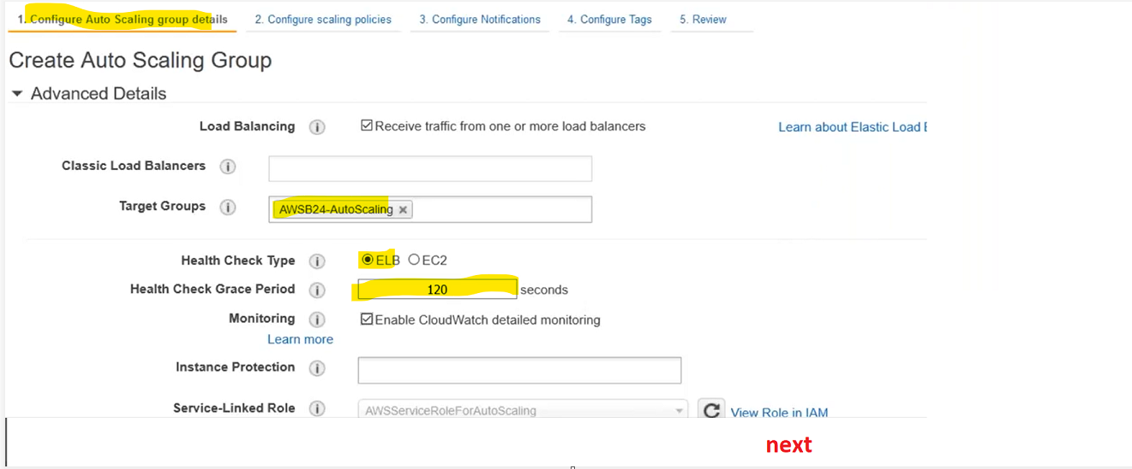

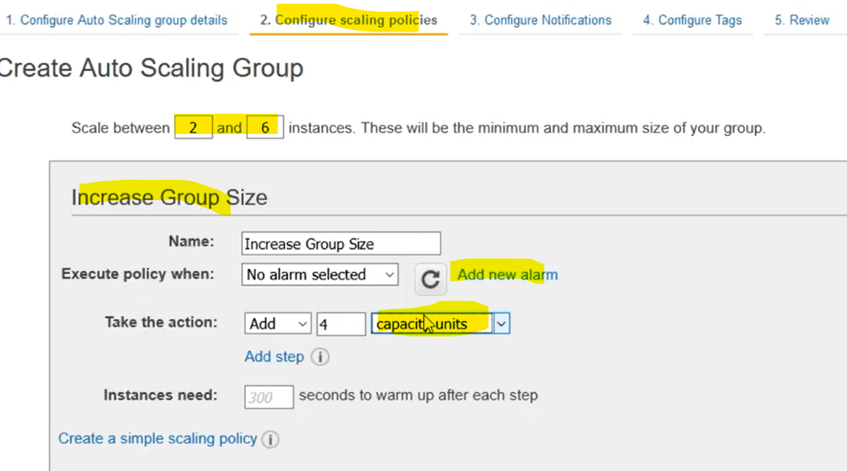

Create a policy for increase and decrease

Auto scalling script use when launch configuration time in user data

#!/bin/bash

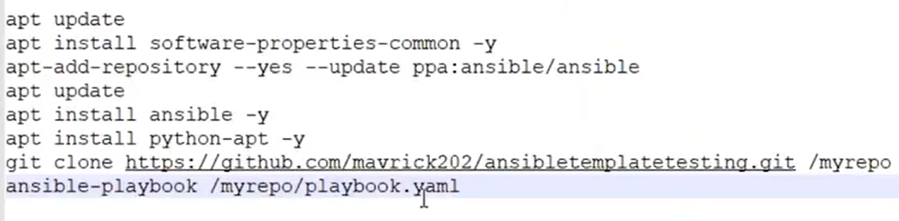

1. Put stress in all vms using stress cmd increase the load and create a new vm.

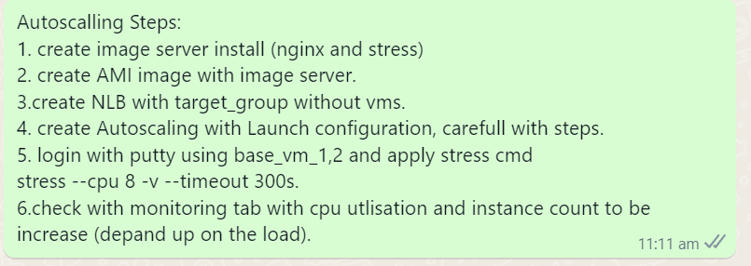

CDN (or) Cloudfront:

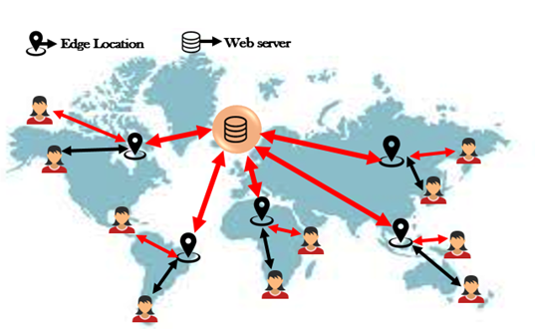

IAM:

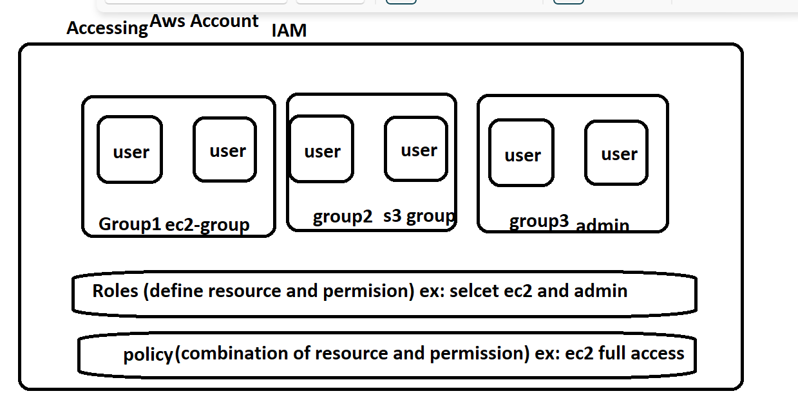

S3 life cycle:

